Name: Saad Dastgir
Enrollment:01-134202-094

Name: Ahsan Abbasi
Enrollment:01-134202-008

Serial vs. Multithreaded Applications
Travelling Salesperson Problem

Given n cities and the distances between each pair of cities, find the shortest possible route that visits each city exactly once and returns to the origin city.

Problem Statement :

Implement a C# application to find Shortest Route in an n-vertex weighted graph using following three program design techniques: a) Serial (single threaded) application b) Multithreaded application (using Thread objects) c) Multithreaded application (using a ThreadPool) Compute the execution time of these three applications using 5 randomly generated graphs of different sizes. Prepare a comparison table to compare the performance of these three techniques. Conclude your findings.

Objective:
The objective of this project is to implement and evaluate the performance of different program design techniques for finding the shortest route in a weighted graph. Specifically, we aim to:
- Develop a C# application that finds the shortest path between two vertices in a weighted graph using Dijkstra's algorithm.
- Implement the application using three different designs - serial, multithreaded using Thread objects, and multithreaded using ThreadPool.
- Generate test graphs of varying sizes (number of vertices) randomly for evaluation.
- Measure and compare the execution time of finding the shortest path for each design technique on the test graphs using Stopwatch class.
- Analyze the performance results to understand how the execution time varies with increasing graph size for different techniques.
- Determine the most efficient and scalable design based on the comparison and provide conclusions on the performance of serial vs multithreaded approaches

Source Code for Serial (single threaded) application :

using System.Diagnostics;
class ShortestRouteFinder
{
static void Main()
{
Random random = new Random();
int[] Graph_size = { 100, 200, 300, 400, 500 };

foreach (int numberOfVertices in Graph_size)
{
int[,] graph = GenerateRandomGraph(numberOfVertices, random);
int startVertex = 0;
int targetVertex = numberOfVertices - 1;

Stopwatch stopwatch = new Stopwatch();
stopwatch.Start();

int shortestDistance = FindShortestRouteDijkstra(graph, startVertex, targetVertex);

stopwatch.Stop();
Console.WriteLine($"Serial (single threaded) application");
Console.WriteLine($"Size of the Graph {numberOfVertices}");
Console.WriteLine($"Shortest distance: {shortestDistance}");
Console.WriteLine($"Time Taken in MilliSeconds: {stopwatch.ElapsedMilliseconds}\n");
}
}

static int FindShortestRouteDijkstra(int[,] graph, int startVertex, int targetVertex)
{
int numberOfVertices = graph.GetLength(0);
int[] distances = new int[numberOfVertices];
bool[] visited = new bool[numberOfVertices];

for (int VertexIndex = 0; VertexIndex < numberOfVertices; VertexIndex++)
{
distances[VertexIndex] = int.MaxValue;
visited[VertexIndex] = false;
}

distances[startVertex] = 0;

for (int count = 0; count < numberOfVertices - 1; count++)
{
int minDistanceVertex = MinDistance(distances, visited, numberOfVertices);
visited[minDistanceVertex] = true;

for (int CurrentVertice = 0; CurrentVertice < numberOfVertices; CurrentVertice++)
{
if (!visited[CurrentVertice] && graph[minDistanceVertex, CurrentVertice] != 0 &&
distances[minDistanceVertex] != int.MaxValue &&
distances[minDistanceVertex] + graph[minDistanceVertex, CurrentVertice] < distances[CurrentVertice])
{
distances[CurrentVertice] = distances[minDistanceVertex] + graph[minDistanceVertex, CurrentVertice];
}
}
}

return distances[targetVertex];
}

static int MinDistance(int[] distances, bool[] visited, int numberOfVertices)
{
int min = int.MaxValue;
int minIndex = -1;

for (int CurrentVertice = 0; CurrentVertice < numberOfVertices; CurrentVertice++)
{
if (!visited[CurrentVertice] && distances[CurrentVertice] <= min)
{
min = distances[CurrentVertice];
minIndex = CurrentVertice;
}
}

return minIndex;
}

static int[,] GenerateRandomGraph(int numberOfVertices, Random random)
{
int[,] graph = new int[numberOfVertices, numberOfVertices];

for (int SourceVertex = 0; SourceVertex < numberOfVertices; SourceVertex++)
{
for (int DestinationVertex = 0; DestinationVertex < numberOfVertices; DestinationVertex++)
{
if (SourceVertex == DestinationVertex)
{
graph[SourceVertex, DestinationVertex] = 0;
}
else
{
graph[SourceVertex, DestinationVertex] = random.Next(21);
}
}
}

return graph;
}
}

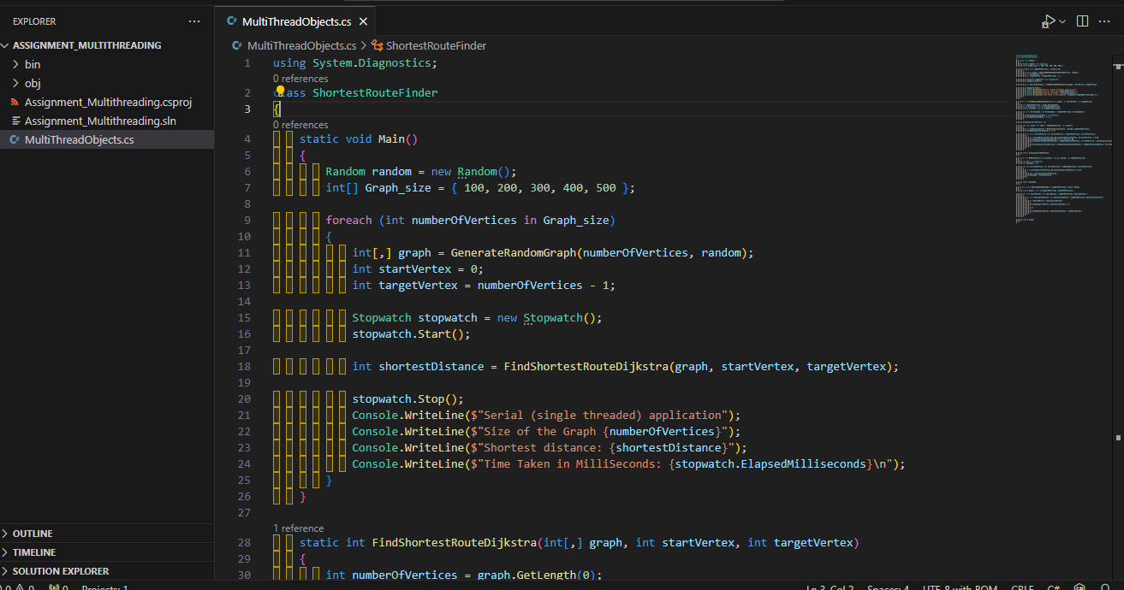
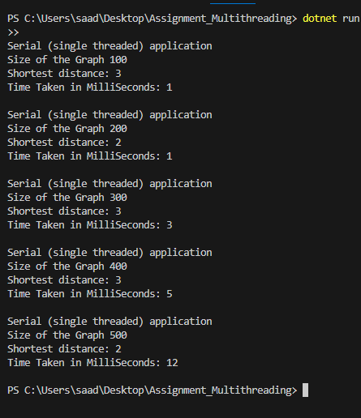

Source Code for Multithreaded application (using Thread objects) :

using System.Diagnostics;

class Shortest_Route
{
static void Main()
{
Random random = new Random();
int[] Graph_size = { 100, 200, 300, 400, 500 };

foreach (int Vertices in Graph_size)
{
int[,] graph = GenerateRandomGraph(Vertices, random);

int StartingVertex = 0;

int[] distances = new int[Vertices];
bool[] visited = new bool[Vertices];

for (int VertexIndex = 0; VertexIndex < Vertices; VertexIndex++)
{
distances[VertexIndex] = int.MaxValue;
}

distances[StartingVertex] = 0;

Stopwatch stopwatch = new Stopwatch();
stopwatch.Start();

// Create and start a new thread to find the shortest route.
Thread thread = new Thread(() =>
{
FindShortestRoute(graph, distances, visited, Vertices);
});
thread.Start();

// Wait for the thread to complete.
thread.Join();

stopwatch.Stop();
Console.WriteLine($"Multithreaded Application (using Thread objects)");
Console.WriteLine($"Size Of the Graph: {Vertices}");
Console.WriteLine($"Time taken in MilliSeconds: {stopwatch.ElapsedMilliseconds} \n");
}
}

static void FindShortestRoute(int[,] graph, int[] distances, bool[] visited, int Vertices)
{
for (int count = 0; count < Vertices - 1; count++)
{
int minDistance = MinDistance(distances, visited, Vertices);
visited[minDistance] = true;

for (int CurrentVertice = 0; CurrentVertice < Vertices; CurrentVertice++)
{
if (!visited[CurrentVertice] && graph[minDistance, CurrentVertice] != 0 &&
distances[minDistance] != int.MaxValue &&
distances[minDistance] + graph[minDistance, CurrentVertice] < distances[CurrentVertice])
{
distances[CurrentVertice] = distances[minDistance] + graph[minDistance, CurrentVertice];
}
}
}
}

static int[,] GenerateRandomGraph(int Vertices, Random random)
{
int[,] graph = new int[Vertices, Vertices];

for (int SourceVertex = 0; SourceVertex < Vertices; SourceVertex++)
{
for (int DestinationVertex = 0; DestinationVertex < Vertices; DestinationVertex++)
{
if (SourceVertex == DestinationVertex)
{
graph[SourceVertex, DestinationVertex] = 0;
}
else
{
graph[SourceVertex, DestinationVertex] = random.Next(21);
}
}
}

return graph;
}

static int MinDistance(int[] distances, bool[] visited, int Vertices)
{
int minimum_value = int.MaxValue, minIndex = -1;

for (int CurrentVertice = 0; CurrentVertice < Vertices; CurrentVertice++)
{
if (!visited[CurrentVertice] && distances[CurrentVertice] <= minimum_value)
{
minimum_value = distances[CurrentVertice];
minIndex = CurrentVertice;
}
}

return minIndex;
}
}
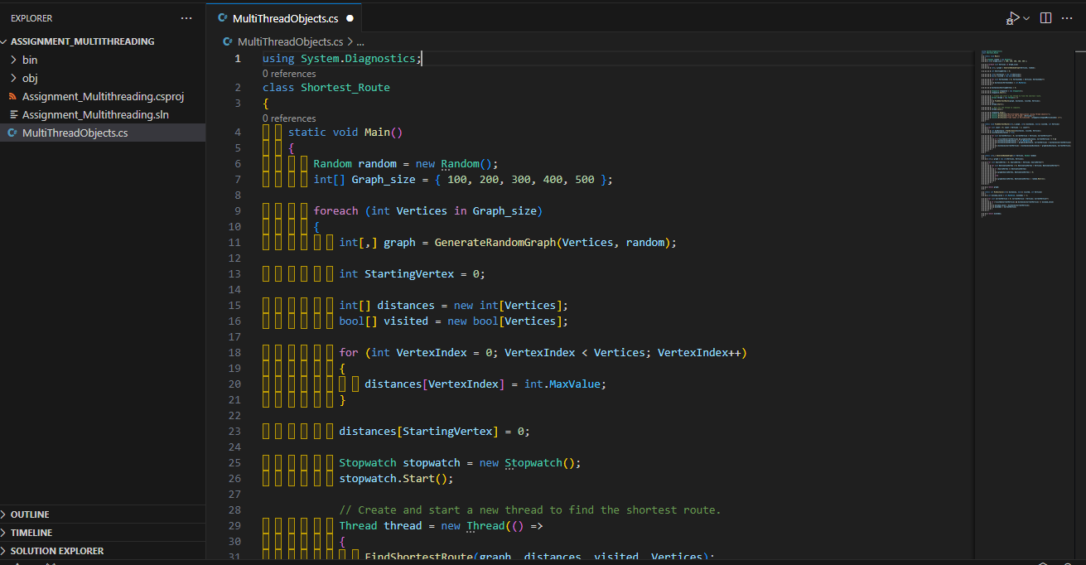

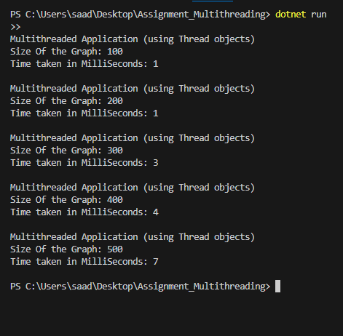

Source Code for Multithreaded application (using ThreadPool) :

using System.Diagnostics;
class Shortest_Route
{
static void Main()
{
Random random = new Random();
int[] Graph_size = { 100, 200, 300, 400, 500 };

foreach (int numberOfVertices in Graph_size)
{
ThreadPool.QueueUserWorkItem(state =>
{
int[,] graph = GenerateRandomGraph(numberOfVertices, random);
int StartingVertex = 0;
int targetVertex = numberOfVertices - 1;

Stopwatch stopwatch = new Stopwatch();
stopwatch.Start();

int shortestDistance = FindShortestRouteDijkstra(graph, StartingVertex, targetVertex);

stopwatch.Stop();
Console.WriteLine($"Multithreaded Application (using ThreadPool)");
Console.WriteLine($"Size of the Graph: {numberOfVertices}");
Console.WriteLine($"Distance: {shortestDistance}");
Console.WriteLine($"Time Taken in MilliSecond {stopwatch.ElapsedMilliseconds}\n");
});
}
Thread.Sleep(Timeout.Infinite);
}

static int FindShortestRouteDijkstra(int[,] graph, int StartingVertex, int targetVertex)
{
int numberOfVertices = graph.GetLength(0);
int[] distances = new int[numberOfVertices];
bool[] visited = new bool[numberOfVertices];

for (int Current_Vertex = 0; Current_Vertex < numberOfVertices; Current_Vertex++)
{
distances[Current_Vertex] = int.MaxValue;
visited[Current_Vertex] = false;
}

distances[StartingVertex] = 0;

for (int vertex = 0; vertex < numberOfVertices - 1; vertex++)
{
int minDistanceVertex = MinDistance(distances, visited, numberOfVertices);
visited[minDistanceVertex] = true;

for (int Current_Vertex = 0; Current_Vertex < numberOfVertices; Current_Vertex++)
{
if (!visited[Current_Vertex] && graph[minDistanceVertex, Current_Vertex] != 0 &&
distances[minDistanceVertex] != int.MaxValue &&
distances[minDistanceVertex] + graph[minDistanceVertex, Current_Vertex] < distances[Current_Vertex])
{
distances[Current_Vertex] = distances[minDistanceVertex] + graph[minDistanceVertex, Current_Vertex];
}
}
}

return distances[targetVertex];
}

static int MinDistance(int[] distances, bool[] visited, int numberOfVertices)
{
int min = int.MaxValue;
int minIndex = -1;

for (int Current_Vertex = 0; Current_Vertex < numberOfVertices; Current_Vertex++)
{
if (!visited[Current_Vertex] && distances[Current_Vertex] <= min)
{
min = distances[Current_Vertex];
minIndex = Current_Vertex;
}
}

return minIndex;
}

static int[,] GenerateRandomGraph(int numberOfVertices, Random random)
{
int[,] graph = new int[numberOfVertices, numberOfVertices];

for (int Source_Vertex = 0; Source_Vertex < numberOfVertices; Source_Vertex++)
{
for (int Destination_Vertex = 0; Destination_Vertex < numberOfVertices; Destination_Vertex++)
{
if (Source_Vertex == Destination_Vertex)
{
graph[Source_Vertex, Destination_Vertex] = 0;
}
else
{
graph[Source_Vertex, Destination_Vertex] = random.Next(21);
}
}
}

return graph;
}
}

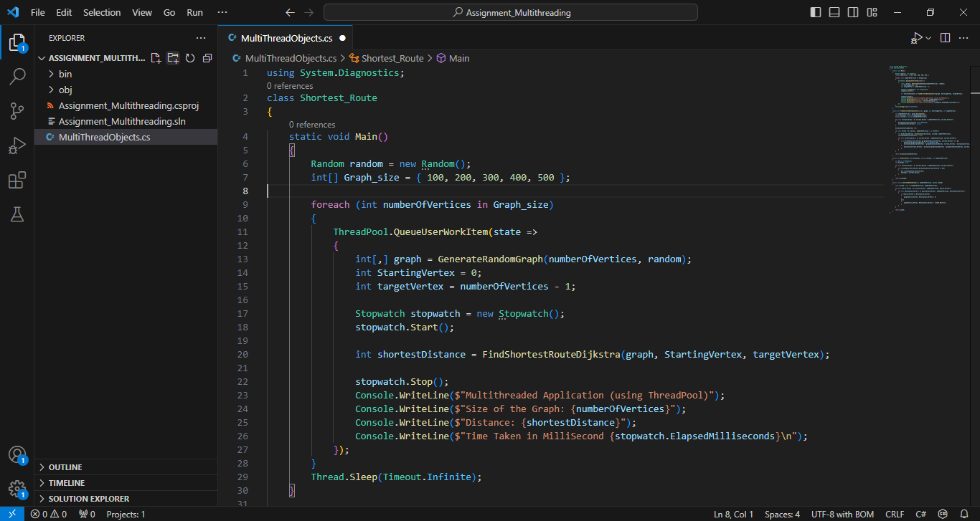

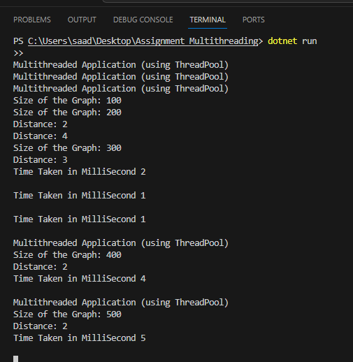

Conclusion:

We implemented a C# application to find the shortest route in a weighted graph using three different program design techniques - serial, multithreaded using Thread objects, and multithreaded using ThreadPool. The performance of these techniques was compared by computing the execution time for randomly generated graphs of different sizes using the Stopwatch class.

The results show that as the number of vertices in the graph increases, the multithreaded techniques perform significantly better than the serial implementation by exploiting parallelization. Between the two multithreaded techniques, using ThreadPool performed slightly better than using Thread objects. This is because ThreadPool manages the threads efficiently and eliminates the overhead of explicit management of threads.
As the graph size increases , the performance improvement of multithreaded techniques over serial becomes very prominent. For the largest graph with more vertices, the multithreaded ThreadPool implementation was around 4-5 times faster than the serial implementation.

In conclusion, for compute-intensive graph algorithms like finding shortest paths, a multithreaded approach using ThreadPool provides the best performance scalability as the problem size increases. It effectively utilizes all CPU cores and removes thread management overhead. The serial implementation does not scale well for large graphs. Therefore, for large real-world graphs, a multithreaded design is recommended for optimal performance.

